How to Submit GotSport Background Check
- Go to GotSport via the following link: https://system.gotsport.com/
- CASA will create an account for you. Username is the email address that you used to register your child. Default password is ‘casasoccer’ (you can change this if you want).
- Click on ‘Account’. Enter your birthdate, scroll to bottom and click on ‘Save’.
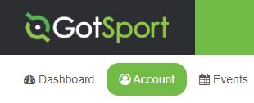
- Click on ‘Dashboard’.
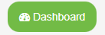
- Click on ‘Requirements’ – Find the line that says ‘Background Check’ and click on ‘Details’.
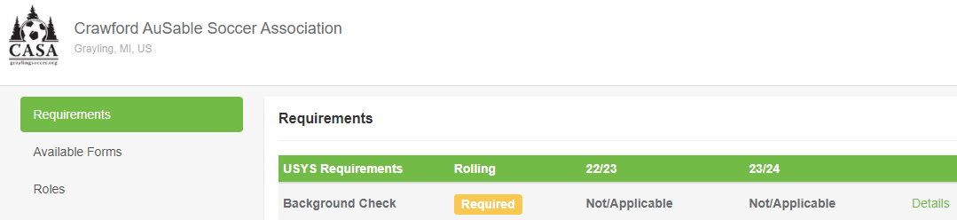
NOTE - For those that have previously submitted a background check:
Your background check is good for one year. By clicking on ‘Details’ you can see when you last submitted a background check. You will receive an email two weeks prior to expiration. If Background Check states ‘Fulfilled’ this means that you previously submitted a background check and this has not yet expired. If you are participating in the upcoming season and your background check will expire before the season ends, you should submit a new background check prior to the upcoming season. We do not want to worry about background checks expiring during the season!
- Click on ‘Submit New Report’.
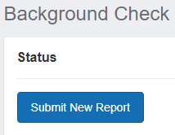
- Complete all required fields, sign, and click on ‘Submit’.
- Your background check will not be processed until you pay the $7.50 fee (you will be reimbursed by CASA). Click on ‘Credit Card Checkout’.
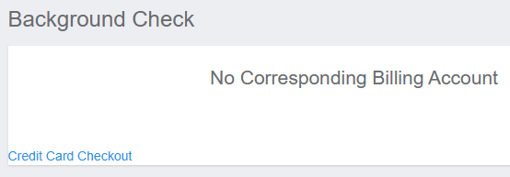
- Enter your credit card information and click on ‘Pay’.
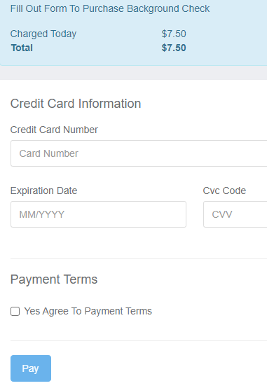
- If you see ‘Payment Successful’, you are all done!

- If you did not complete check out right away, you can complete the following steps to pay. Click on ‘Details’ to get back to the background check screen.
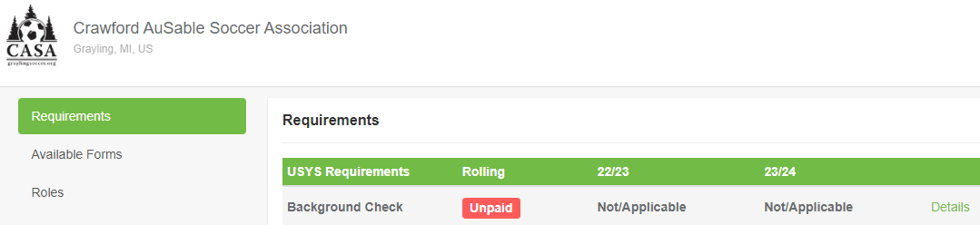
- Click on the ‘cart’ icon.
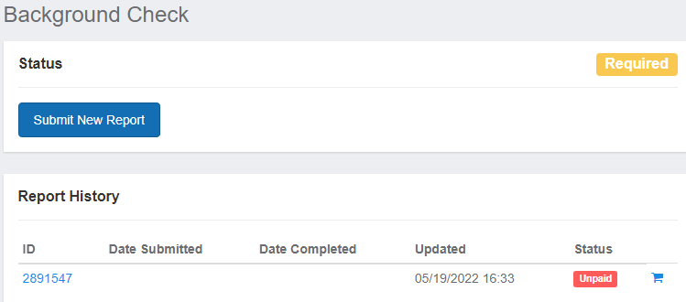
- Complete steps 8 and 9 above to complete payment.

